Preaching Christ, Ministering God’s Love on campus
P.O. BOX 16631, Wandegeya
christianunion.mak@gmail.com Face book: M.U.K Christian Union
Twitter : @mukmain cu
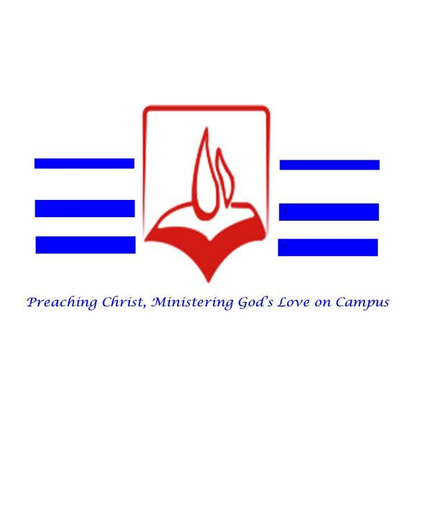
CHRISTIAN UNION

MAKERERE UNIVERSITY

THEME: Restoration, Acts 1:6-8, You shall receive power when the Holy Spirit comes
THE MAKERERE UNIVERSITY CHRISTIAN UNION PROFILE.
Introduction
Makerere University Christian Union is a well-established Christian student fellowship operating at Makerere University in Kampala, Uganda. It’s one of the oldest and most active student Christian groups in the country. The Christian Union unites all Christian students at campus made up of currently 26 fellowships for students from; colleges, Halls of residence, Hostels, and gospel mission teams. The Makerere University Christian Union is a student-led body of Christian students from different evangelical denominations who come together to worship, study the Bible, pray, and share the Christian faith on campus. It’s focused on encouraging spiritual growth, prayer, fellowship, and evangelism among students at Makerere university while students are busy pursuing their academic qualifications.
Vision of the Christian Union.
Reaching out to Makerere University Students with the gospel of Christ to impact and transform
the society holistically.
Mission of the Makerere University Christian Union.
To proclaim the lordship of Jesus Christ among students through Bible-based teaching, discipleship, prayer, fellowship, and fellowship and evangelism, enabling them to grow in the Christian faith, character and service.
Motto
Preaching Christ and ministering God's Love on campus and beyond
Objectives
The aims and objectives of the Christian union are to;
- Promote growth to maturity in the Christian faith and life among the members of
the Union by holding fellowships, prayer meetings, missions, bible studies,
seminars, retreats, outreaches and the like, with a view to promote discipleship
and leadership development.
- Encourage Christianity as a lifestyle of commitment and heart devotion to Christ,
so as to have spiritual, social, physical and academic impact in the Makerere
Community.
- Promote and maintain the spiritual interests and safeguard the spiritual welfare of
the members from false doctrines and worldly living.
- Foster and promote unity and co-operation among all the evangelical groups of Makerere University.
- Affiliate and create dialogue with the local evangelical churches as well as local/National Para-church organizations.
Core Values
- Unity and teamwork
- Accountability and integrity
- Bible centered
- Love
- Servant leadership
Doctrinal base of The Christian Union of Makerere University.
The doctrinal basis of faith of the union is the fundamental truths of Christianity,
including
- The Unity of the Father, Son and the Holy Spirit in the Godhead.
- The Unity of the Father, Son and the Holy Spirit in the Godhead.
- The divine inspiration and entire truthfulness and trustworthiness of the Holy
Scriptures as originally given
- The supreme authority of the Holy Scriptures as originally given, in all matters of
faith and conduct.
- . Redemption from the guilt, penalty, dominion and pollution of sin, solely through
the sacrificial death of the Lord Jesus Christ (as our substitute), the incarnate Son of
God.
- The bodily resurrection of our Lord Jesus Christ from the dead and his ascension to
the right hand of God the Father.
- The justification of a sinner by the Grace of God through Faith in Jesus Christ
alone.
- The presence and power of the Holy Spirit in the work of regeneration.
- The indwelling and work of the Holy Spirit in the believer.
- The unity of all believers in Christ without respect of persons, and without
discrimination on account of race, color, nation, social position or otherwise.
- The one Holy universal church, which is the body of Christ and to which all true
believers belong.
- The expectation of the personal return of the Lord Jesus Christ.
This doctrinal base aligns with the core evangelical doctrinal basis of the International Fellowship of Evangelical Students (IFES), the global movement with which FOCUS Uganda and Makerere CU are historically connected.
It reflects traditional evangelical Christian teaching that is consistent with the identity of CU as an inter-denominational fellowship centered on the gospel and biblical discipleship.
Membership of the Christian Union
Membership is open to all students of Makerere University who confess faith in Jesus Christ as Lord and Savior and are willing to uphold the Union’s Statement of Faith (Doctrinal Basis), objectives, and values.
Affiliation
The Christian Union at Makerere is under FOCUS Uganda (Fellowship of Christian Unions) an evangelical interdenominational body that supports student ministries in universities and institutions of higher learning across Uganda. Makerere’s CU played a key role in the foundation and growth of student Christian fellowships in higher learning institutions across the country. The Christian union is interdenominational and it partners with different sound doctrine churches like Full gospel Church, United Christian Centre, Redeemed of Lord Evangelical Church, St. Francis Chapel. Christian Union is affiliated to the St. Francis Chapel for administrative supervision within the University. Another major stakeholder of the Christian Union is the Alumni of the Christian Union who comprise of the previous leaders and members of different generations who graduated, the alumni family is united by a fellowship called the Alumni Christian Fellowship (ACF) which provides guidance and counsel to the Christian Union in its operations.
History and Legacy
The Christian Union at Makerere was formed in 1962 and has been active on campus ever since then. It’s historically significant because it helped spark the wider Fellowship of Christian Unions (FOCUS) Uganda movement that supports similar Christian groups across universities and other tertiary institutions in Uganda and has nurtured prominent national figures in the market place and in the body of Christ like Justice Michael Chibita, DR. James Magara, Pastor Laban Jumba, Pastor Ben Ocholla Jennifer Musisi, Allen Kajina, Pastor David Makoko among others.
It has celebrated major anniversaries like 50th and 60th years anniversary marking decades of ministry and student impact.
Activities
While details may vary by year and leadership, typical activities of Makerere University Christian Union include: Worship meetings and Bible studies for students, prayer altars, career guidance.
Evangelistic In reaches on campus and in the surrounding community like in the ten colleges of Makerere University, Halls of residence and Hostels to reach out to our fellow students while at campus to receive the gift of salvation and this is done on Saturday from 10am to 1pm.
Evangelism outreaches in rural areas (this is done through gospel missions which are conducted at the beginning of the second semester in the first week.) and this done once in a whole academic year. For example, last year’s outreach happened in Kasese district from 19th to 26th January 2025 where a team of 70 Makerere university missioners impacted the community and 414 souls received salvation which was a good harvest for the kingdom of the God and fulfilling the great commission that our lord Jesus Christ left for us.
In conclusion, Makerere University Christian Union stands as Christian body that is interdominion and student-led aimed at nurturing students spiritually while they pursue academic excellence through bible study, discipleship, worship both on campus and beyond. It remains a vital
instrument for transforming students to influence the church, the nation and society for the glory of the God.

